CS4042D Web Programming

**The “Webcoursera” Website**

Documentation



Group 17

Dhanunath K B180319CS

Akshay A B180034CS

Mandeep Singh Chhikara B180312CS

# 

# Expected Outcome

Hosting a website (using HTML,CSS and Javascript) that serves as an online platform for learning a few courses such as HTML,Python,Java etc. having a “login” and “sign up” feature as well as the course details and materials available to those who have logged in. The course details such as the title, duration etc, would be included for each of the lectures in the course material; the course materials would ideally include recorded sessions. Along with these, certain features such as filtering through the videos, or searching for a particular course is also made available.

# Achieved Outcome

To make this documentation easier and more entertaining to read, some visual representations of the final website is shown below.

**Home Page**

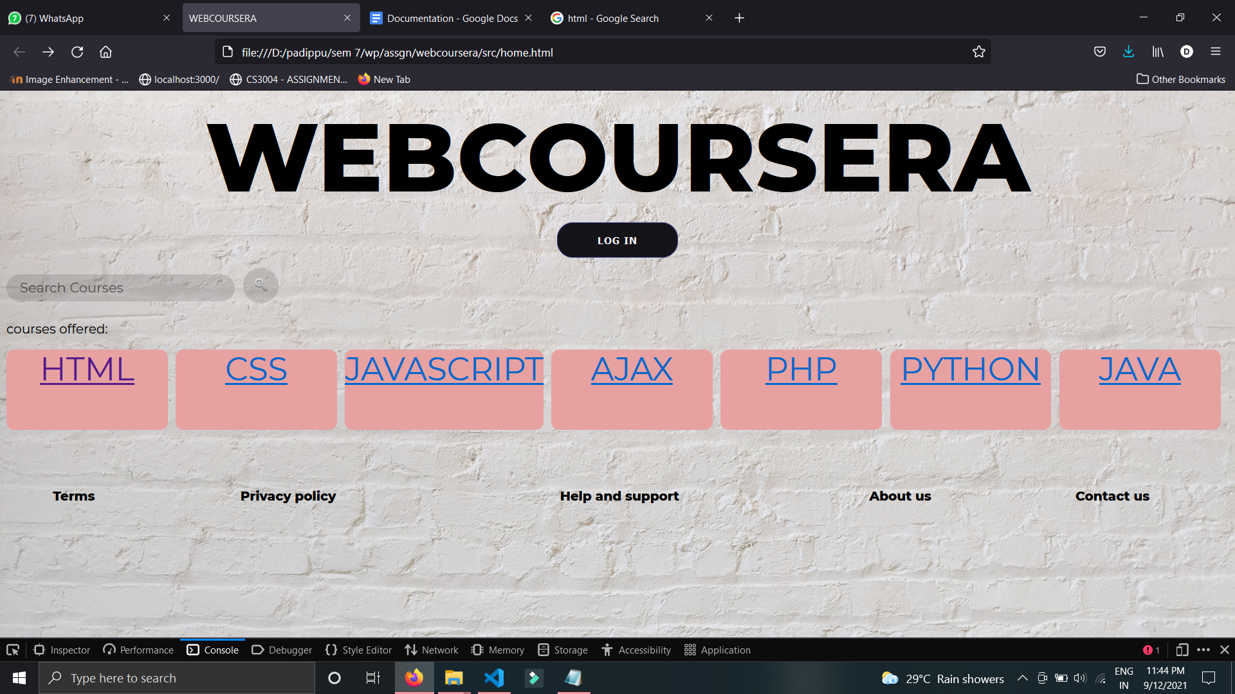

**Login and Sign up Page**

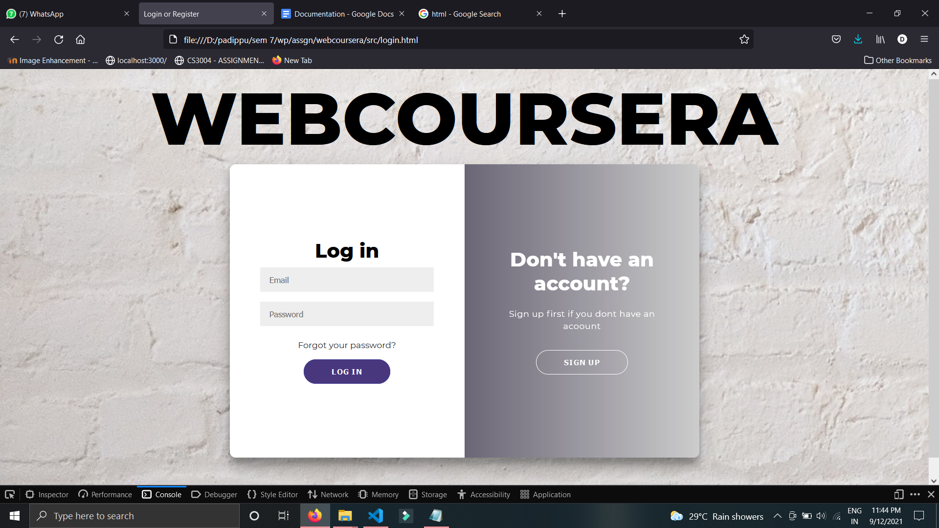

**A few course Pages**

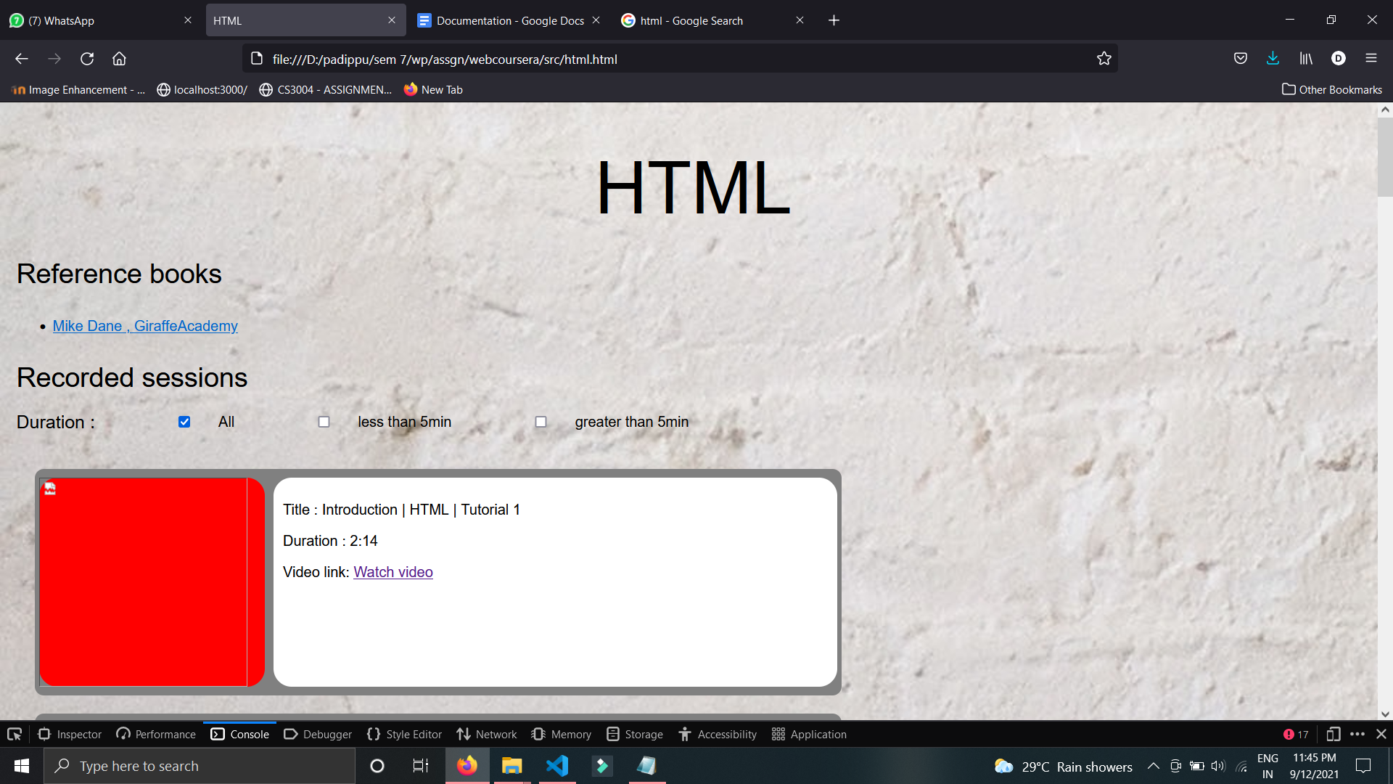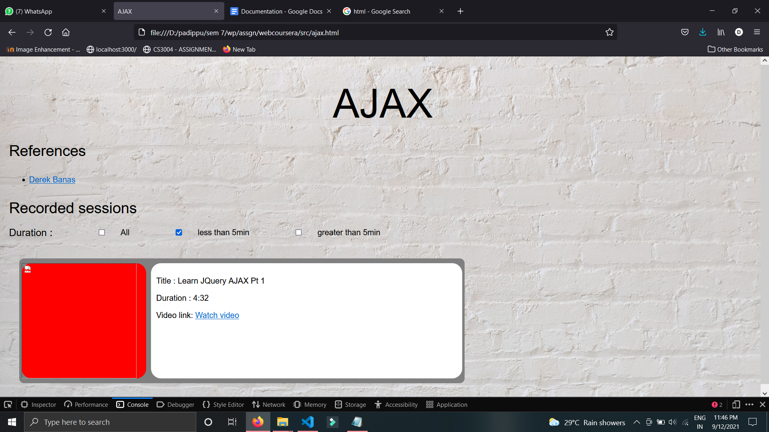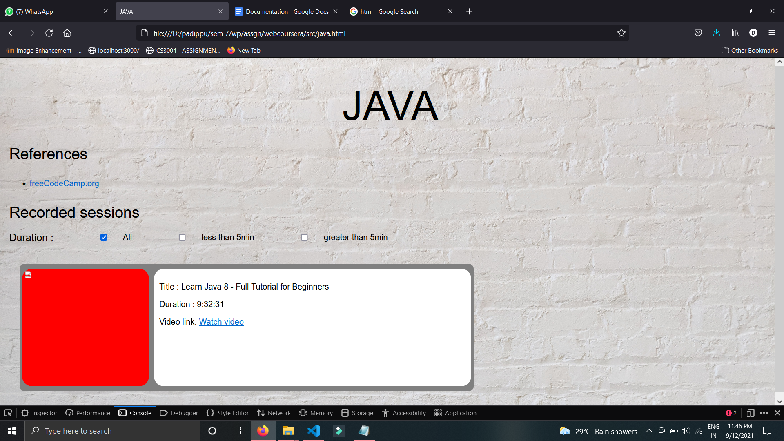

Therefore all the desired features have been successfully implemented in the website.